|  |  |  |
| --- | --- | --- |
| **Tech Saksham**  Capstone Project Report  **ARTIFICIAL INTELLIGENCE AND MACHINE LEARNING FUNDAMENTALS** |  |  |

**“AI chatbot using chat GPT”**

**“College of engineering,Guindy”**

|  |  |
| --- | --- |
| **NM ID** | **NAME** |
| Au2021109304 | KARUPPU EZHILARASAN C |

|  |  |
| --- | --- |
|  |  |
| RAMAR | Trainer Name |
|  | Master Trainer |

**ABSTRACT**

For the completion of NM course on AI&ML , a chatbot was created using python language.This project is created with set of python codes that uses for and while loops.The main idea is to greet the user with some typed message and answering based upon the upcoming inputs.

It leads to a conversation between the user and the AI system behind it.It can work with various platforms and so on.

**INDEX**

|  |  |  |
| --- | --- | --- |
| **Sr. No.** | **Table of Contents** | **Page No.** |
| 1 | Chapter 1: Introduction |  |
| 2 | Chapter 2: Services and Tools Required |  |
| 3 | Chapter 3: Project Architecture |  |
| 4 | Chapter 4: Project Outcome |  |
| 5 | Conclusion |  |
| 6 | Future Scope |  |
| 7 | References |  |
| 8 | Code |  |

**CHAPTER 1**

**INTRODUCTION**

* 1. **Problem Statement**

To create a chatbot using ChatGPT as project using python as a programming language.

* 1. **Proposed solution**

A chat bot was created using python.

* 1. **Feature**

User can start chatting with typed messages.

**1.4Advantages**

Used in various platforms as basic code.

**1.5. Scope**

Automation of customer queries.

**1.6 Future work**

Use it for educational purposes.

**CHAPTER 2**

**SERVICES AND TOOLS REQUIRED**

**2.1 Services Used**

**1.INTERNET**

**2.2 Tools and Software used**

**1.CHATGPT**

**2.PYTHON**

**CHAPTER 3**

**PROJECT ARCHITECTURE**

**3.1 Architecture**

**USER FRONTEND BACKEND**

|  |  |  |
| --- | --- | --- |
| **Customers**  **Mail supports** | **HTML 5**  **Python** | **NODEJS 14.0**  **Database** |

**CHAPTER 4**

**PROJECT OUTCOME**

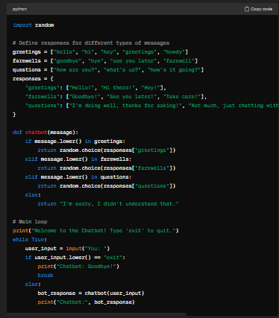

**FUTURE SCOPE**

**QUERY AUTOMATION**

**DOUBT CLEARING IN EDUCATION**

**REFERENCES**

**https://chat.openai.com/**

**CODE**

**Please Provide Code through Git Hub Repo Link**

import random

# Define responses for different types of messages

greetings = ["hello", "hi", "hey", "greetings", "howdy"]

farewells = ["goodbye", "bye", "see you later", "farewell"]

questions = ["how are you?", "what's up?", "how's it going?"]

responses = {

"greetings": ["Hello!", "Hi there!", "Hey!"],

"farewells": ["Goodbye!", "See you later!", "Take care!"],

"questions": ["I'm doing well, thanks for asking!", "Not much, just chatting with you!", "It's going fine, how about you?"]

}

def chatbot(message):

if message.lower() in greetings:

return random.choice(responses["greetings"])

elif message.lower() in farewells:

return random.choice(responses["farewells"])

elif message.lower() in questions:

return random.choice(responses["questions"])

else:

return "I'm sorry, I didn't understand that."

# Main loop

print("Welcome to the Chatbot! Type 'exit' to quit.")

while True:

user_input = input("You: ")

if user_input.lower() == "exit":

print("Chatbot: Goodbye!")

break

else:

bot_response = chatbot(user_input)

print("Chatbot:", bot_response)